CS 62 Quiz 4

February 20, 2015

Name:_______________________________________________________

1a. (2 pts) Give one advantage that a doubly linked list has over a singly linked list. Explain.

b. (2 pts) Give one disadvantage that a doubly linked list has compared to a singly linked list. Explain.

Assume you are given an implementation of a queue that uses a singly linked list with only a head pointer as shown below (this may or may not be different from the implementation we looked at in class). You are told that head points to the front of the queue.

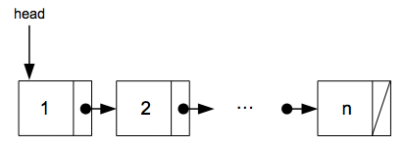

(a) (3 pts.) Using big-oh notation, what do you expect the running time of the enqueue(E value) method to be? (Recall that enqueue adds an element to the rear of the queue.)

(b) (3 pts.) Using big-oh notation, what do you expect the running time of the dequeue() method to be? (Recall that dequeue removes an element from the front of the list.)