Lecture 11 Exercises
CS 51P – Fall 2019

$x^{n}$ is equal to : $x^{n}=x⋅x⋯x$

Unless it is very small, in which case is it equal to:

Define a recursive function exp that takes two arguments (x and n, both ints) and returns the value $x^{n}$

Define a recursive function exp that takes two arguments (x and n, both ints) and returns the value $x^{n}$ using the square_and_mutliply recursive definition

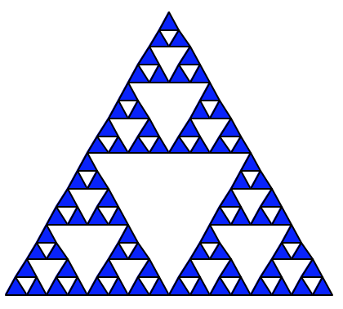
A triangle_drawing_2 is:

Unless it is very small, in which case is it:

Define a recursive function triangle_drawing_2(x,y, size) that will produce the image above and count the number of (solid) triangles drawn.. Assume that “really small” means side length (i.e., size) less than 10.

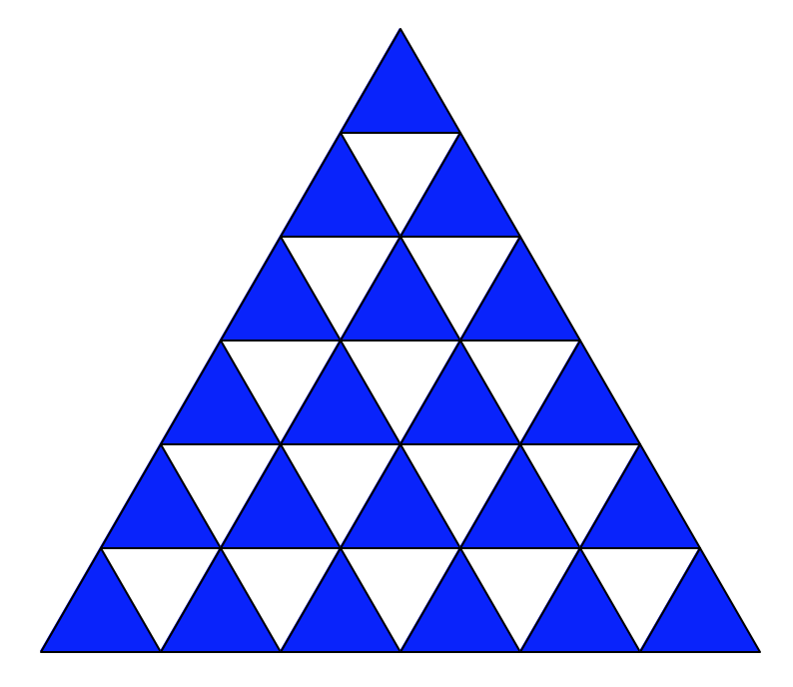

A triangle_drawing_3 is:

Unless it is very small, in which case is it:

Define a recursive function triangle_drawing_3(x,y, size) that will produce the image above. Assume that “really small” means side length (i.e., size) less than 20.

