Lecture 10 Exercises
CS 51P – Fall 2019

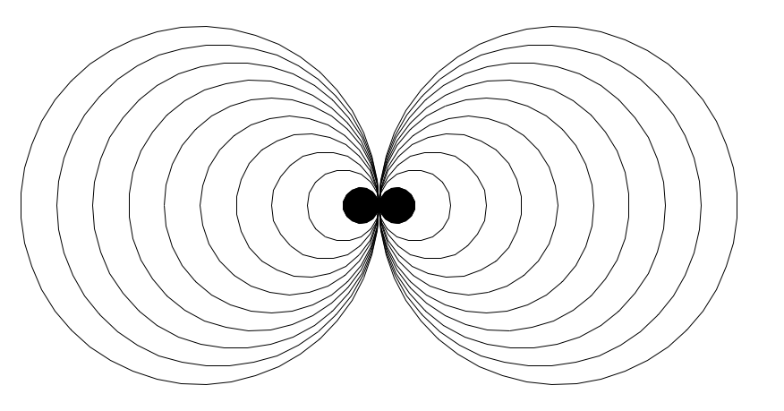

A circle_drawing_2 is:

Unless it is very small, in which case is it:

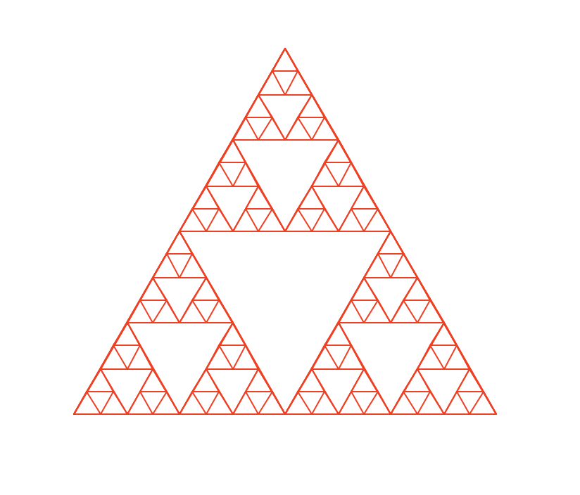

A triangle_drawing is:

Unless it is very small, in which case is it:

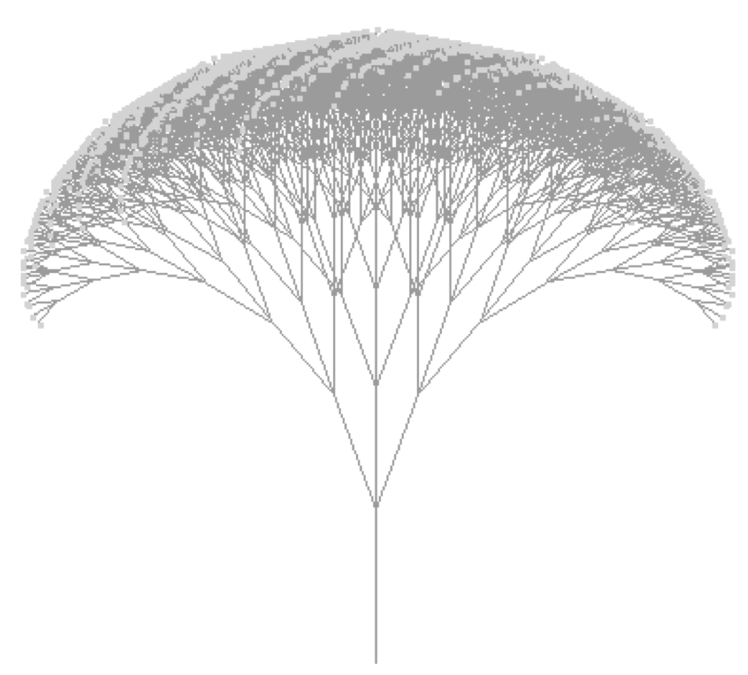

A broccoli is:

Unless it is very small, in which case is it:

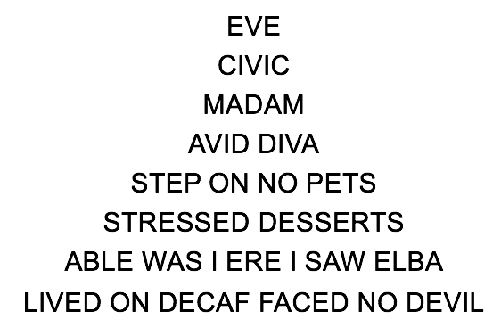

A palindrome is:

Unless it is very small, in which case is it:

Consider the following function. What does mystery(3) evaluate to? What does mystery(5) evaluate to? What does mystery(k) evaluate to?
def mystery(n):
if n == 1:
return 1
else:
return n + mystery(n-1)

Define a function fib which takes a parameter n (an int) and returns the nth Fibonacci number.

